NOISE POLLUTION MONITORING

Phase_5

**PROJECT**

Creating a Noise pollution Monitoring (Internet of Things) involves a combination of hardware, software, and connectivity. While web development technologies may not be the only requirement, they can play a crucial role in creating a user interface for monitoring and controlling the air conditions processing.

**OBJECTIVES**

* **Real-Time Monitoring:** Implement a system capable of continuously monitoring noise levels in various locations within a designated area, providing up-to-the-minute data.
* **Data Collection and Storage:** Develop a robust data collection and storage mechanism to capture noise data, including decibel levels, timestamps, and location information, and store it securely for future analysis.
* **Data Analysis:** Utilize advanced data analytics to process and interpret noise data, identifying trends, patterns, and noise pollution hotspots.
* **Alerts and Notifications:** Implement a real-time alerting system that issues notifications to relevant authorities and the public when noise levels exceed permissible limits, enabling prompt action.

**IoT device setup**

**1. Select Suitable Sensors:**

Choose appropriate noise sensors (microphones or sound level meters) with the necessary sensitivity and accuracy to measure noise levels. Make sure they are compatible with IoT connectivity options.

**2. Choose IoT Hardware:**

Select IoT hardware components such as microcontrollers (e.g., Raspberry Pi, Arduino), IoT development boards (e.g., ESP8266, ESP32), or specialized IoT devices designed for environmental monitoring.

**3. Connect the Sensors:**

Connect the noise sensors to your chosen IoT hardware. Ensure the sensors are properly calibrated.

**4. Power Supply:**

Provide a reliable power source for your IoT devices, which may involve using batteries, solar panels, or a continuous power supply if available.

**5. IoT Communication:**

Choose a communication protocol to transmit data from the sensors to a central server or cloud platform. Common options include Wi-Fi, cellular networks, LoRa (Long Range), Sigfox, or NB-IoT. Ensure the connectivity is reliable in the target environment.

**6. Data Processing and Storage:**

Set up a central server or cloud platform to receive, process, and store the data from your IoT devices. This platform should handle data analysis, visualization, and storage.

**7. Data Security:**

Implement strong security measures to protect the data and the IoT devices from unauthorized access.

**8. Data Analysis Software:**

Develop or integrate software to analyze the noise data in real-time. This may include identifying noise patterns, calculating noise levels, and sending alerts when thresholds are exceeded.

**9. Visualization and Reporting:** - Create a user-friendly interface to visualize the noise data, generate reports, and provide insights to stakeholders. Consider using web dashboards or mobile apps.

**10. Data Analysis and Improvement:** - Continuously analyze the data to identify trends and patterns, and use this information to improve noise mitigation strategies or adapt monitoring locations as needed.

**Platform development**

**1. Choose a Technology Stack:**

Select the appropriate technology stack, including programming languages, frameworks, and databases. Common choices include Python, Node.js, Django, Flask, React, and databases like PostgreSQL or MongoDB.

**2. Data Collection and Integration:**

Implement mechanisms to collect data from noise sensors (IoT devices). This can involve setting up data ingestion pipelines, APIs, or direct sensor connections.

**3. Data Storage:**

Design a database structure to store noise data efficiently. Choose a database management system that suits your data volume and access patterns.

**4. Real-Time Data Processing:**

Develop real-time data processing capabilities to analyze incoming noise data, calculate metrics (e.g., sound levels), and detect anomalies or exceedances of predefined thresholds.

**5. Geospatial Integration (Optional):**

If your platform includes location-based monitoring, integrate a Geographic Information System (GIS) to handle geospatial data and mapping.

**6. User Management and Authentication:**

Implement user management and authentication systems to ensure that only authorized individuals can access and interact with the platform.

**7. Data Visualization:**

Create interactive dashboards and visualization tools to display noise data in a user-friendly way. This can be done using libraries like D3.js, Plotly, or Mapbox for geospatial visualization.

**8. Alerting and Notifications:**

Set up an alerting system to notify users when noise levels exceed predefined thresholds. This can include email alerts, SMS, or push notifications.

**9. Reporting and Analytics:** - Develop reporting features that allow users to generate custom reports and analyze historical noise data. Incorporate data analytics tools as needed.

**10. Data Export:** - Allow users to export data in various formats (e.g., CSV, PDF) for further analysis or compliance reporting.

**11. User Interfaces:** - Create web-based or mobile interfaces for end-users, administrators, and data analysts. Ensure that the interfaces are responsive and user-friendly.

**12. Data Security:** - Implement strong security measures to protect data, including encryption, access controls, and regular security audits.

**13. Compliance and Regulations:** - Ensure that the platform complies with relevant noise pollution regulations and standards, especially if it's used for compliance monitoring.

**Python script for noise monitoring:**

import os

import time

import numpy as np

import pyaudio

import requests

# Constants for your configuration

API_ENDPOINT = 'https://your-api-endpoint.com/noise-data'

SAMPLE_RATE = 44100 # Audio sample rate (Hz)

RECORD_SECONDS = 5 # Duration of each recording (seconds)

# Initialize PyAudio

p = pyaudio.PyAudio()

def record_audio():

print("Recording audio...")

stream = p.open(format=pyaudio.paInt16, channels=1, rate=SAMPLE_RATE, input=True, frames_per_buffer=1024)

frames = []

for _ in range(0, int(SAMPLE_RATE / 1024 * RECORD_SECONDS)):

data = stream.read(1024)

frames.append(data)

stream.stop_stream()

stream.close()

audio_data = b''.join(frames)

return audio_data

def main():

while True:

audio_data = record_audio()

# Calculate noise level (you can use a more complex algorithm)

noise_level = np.frombuffer(audio_data, dtype=np.int16).max()

print(f"Noise level: {noise_level} dB")

# Send data to the server

payload = {

"noise_level": noise_level

}

try:

response = requests.post(API_ENDPOINT, json=payload)

if response.status_code == 200:

print("Data sent successfully.")

else:

print(f"Failed to send data. Status code: {response.status_code}")

except Exception as e:

print(f"Failed to send data: {str(e)}")

time.sleep(60) # Wait for 1 minute before taking the next reading

if __name__ == '__main__':

main()

**IOT SENSOR DESIGN DIAGRAM**

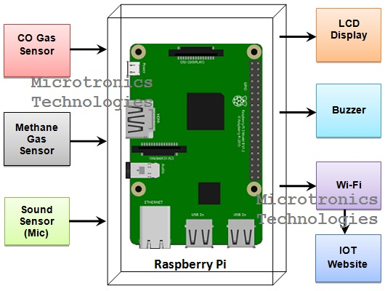

**The IoT devices**

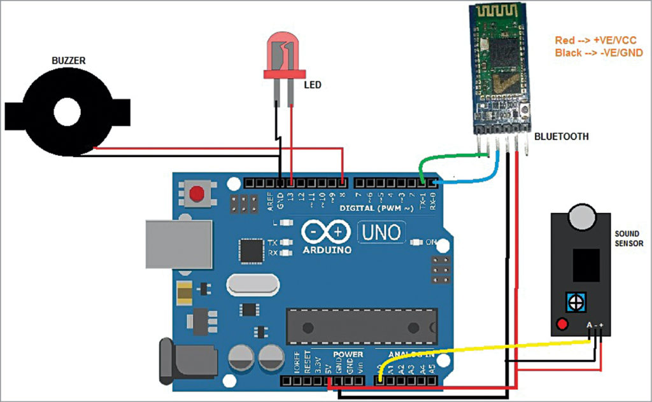

**Schematics**

* Components Needed:
* Microcontroller: Arduino Uno or a similar board (for simplicity).
* Sound Sensor: A microphone sensor or a sound level sensor (e.g., LM386-based) to measure noise levels.
* Wi-Fi Module: ESP8266 or ESP32 for IoT connectivity.
* Power Source: A 5V power supply or a rechargeable battery.
* Voltage Regulator: LM7805 or a similar voltage regulator to provide a stable 5V power supply.
* Resistors: To interface the sound sensor with the microcontroller.
* LEDs: To indicate device status.
* Capacitors: For noise filtering and stability.
* Breadboard or PCB: To assemble the components

**Project in detail:**

**1. Project Objectives:**

The primary objective of this project is to design and implement an IoT-based system for monitoring noise pollution in urban . This system will collect real-time noise data, analyze it, and make the data accessible to authorities, researchers, and the public.

Specific objectives include:

Continuously monitor noise levels at various locations.

Analyze noise data to identify patterns, sources, and trends.

Provide real-time alerts when noise levels exceed permissible limits.

Create user-friendly interfaces for data visualization and reporting.

Encourage community engagement and awareness regarding noise pollution.

**2. Hardware and Sensors:**

Select appropriate hardware components for noise data collection, such as sound sensors (e.g., microphones or sound level meters), microcontrollers (e.g., Arduino or Raspberry Pi), IoT communication modules (e.g., Wi-Fi, cellular, LoRa), and power sources (batteries or solar panels). Ensure the sensors are sensitive, accurate, and weather-resistant.

**3. Data Collection and Communication:**

Connect the sound sensors to microcontrollers, which process and digitize the analog noise data.

Use IoT communication modules to transmit the data to a central server or cloud platform for analysis.

**4. Real-Time Data Analysis:**

Develop software to analyze noise data in real-time to calculate noise levels and detect anomalies.

Use machine learning and data analytics techniques to identify patterns and trends in noise pollution.

**5. User Interfaces:**

Create user-friendly web-based or mobile interfaces for various stakeholders, including authorities, researchers, and the public.

Provide dashboards with real-time noise data visualization, historical data analysis, and geographic mapping if necessary.

**6. Alerts and Notifications:**

Set up an alerting system to notify relevant parties when noise levels exceed predefined thresholds. Alerts can be sent via email, SMS, or push notifications.

**7. Reporting and Analytics:**

Enable users to generate custom reports and perform in-depth data analytics.Provide data export options for further analysis or regulatory compliance.

**8. Geographic Information System (GIS) Integration:**

If the project involves multiple monitoring locations, integrate GIS for geospatial context and mapping of noise data.

**9. Compliance and Regulations:**

Ensure that the monitoring system complies with local noise pollution regulations and standards. Provide compliance reporting features if required.

**CONCLUSION :**

In conclusion, an IoT device for noise pollution monitoring is a valuable tool in addressing the growing concern of noise pollution in urban and industrial environments. Such devices can provide real-time data, enabling informed decisions for mitigating the effects of noise pollution.

**THANK YOU**

**Team name :**

Proj_224688_Team_1

**Team members :**

AJAY.L

DILIP KUMAR.J

YOkESH.J

DHINESHKUMAR.V

**College code :**

4204